A000-Eur-Bulgaria-Stara Zagora-Thrace-Figurine-Steatopygic-Female-Ceramic-Neolithic-5500 BCE

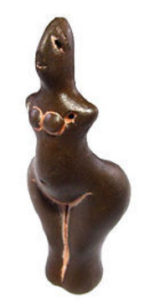 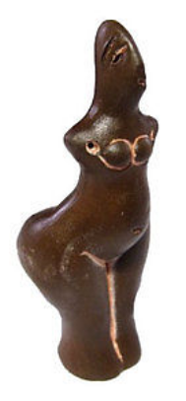 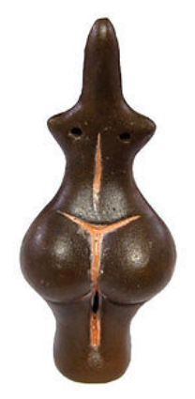 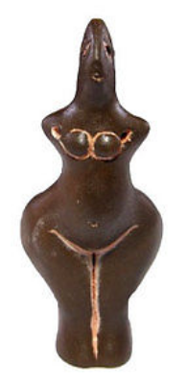

Figs. 1-4. Eur-Bulgaria-Stara Zagora-Thrace-Figurine-Steatopygic-Female-Ceramic-Neolithic-5500 BCE

**Formal Label:** Eur-Bulgaria-Stara Zagora-Thrace-Figurine-Steatopygic-Female-Ceramic-Neolithic-5500 BCE

**Accession Number:** A000

**Display Description:**

The apparent steatopygic condition of this figurine suggests that this physical condition was possible in Eurasian Paleolithic women and in the so-called “Venus figurines.” It is unknown whether this depiction was intended to be lifelike or an exaggeration. Steatopygic conditions can exhibit an angle from 90 to 120 degrees between the back and the buttocks. The condition has been suggested to be genetically induced among peoples of southern Africa, but how this condition is induced among peoples of the European descent remains to be explained.

Khoisan women with steatopygia:

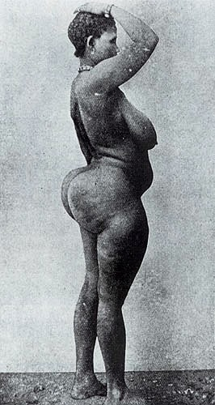 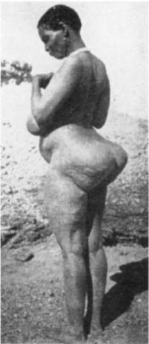 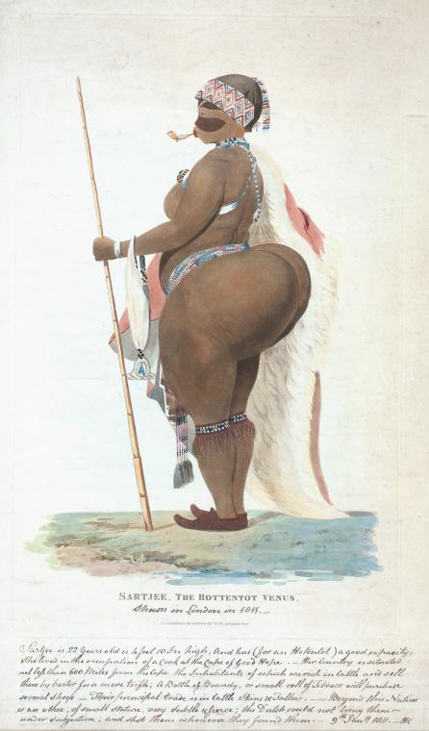 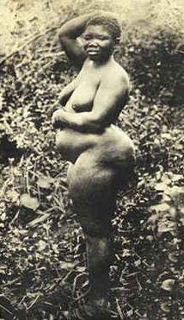 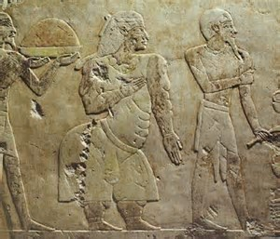

1) <https://upload.wikimedia.org/wikipedia/commons/7/71/Woman_with_steatopygia.jpg>

2) <http://3.bp.blogspot.com/-EXcNDF9N6Qw/T8-Up-PgBjI/AAAAAAAABGQ/Ikhgn-fIr5c/s1600/ncp05010503.jpg>

3)http://3.bp.blogspot.com/_nlc15ExoAhk/TIhMWdmDmZI/AAAAAAAAAGM/8YP9RNsoNo8/s1600/c.jpg

4) <http://news.softpedia.com/images/news2/What-is-Steatopygia-2.jpg>

5) Egyptian, Queen Hatshepsut’s retinue https://www.bing.com/images/search?view=detailV2&ccid=9GrTgbs%2f&id=6175E43BD6E5E86B55BA666DB11D68B3E84635E4&thid=OIP.9GrTgbs_ujXClYU7Q0HyuAEsEB&mediaurl=http%3a%2f%2fi1-news.softpedia-static.com%2fimages%2fnews2%2fWhat-is-Steatopygia-6.jpg&exph=399&expw=465&q=steatopygia&simid=608050535053069650&selectedIndex=9&qpvt=steatopygia

European women with steatopygia:

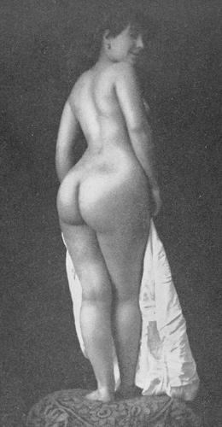 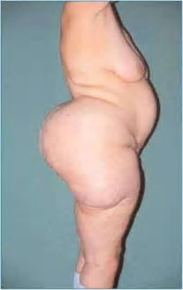  https://tse2.explicit.bing.net/th?id=OIP.wPbNIyN5tQ4mag0M1_m9QgCuD6&pid=Api

1. <https://pictures.abebooks.com/ARSAMANDI/md/md7174130583.jpg>
2. [https://tse1.mm.bing.net/th?id=OIP.WdR_jo7MbPKnCdY- Uy0xVgC9Es&w=189&h=300&c=7&qlt=90&o=4&dpr=1.5&pid=1.7](https://tse1.mm.bing.net/th?id=OIP.WdR_jo7MbPKnCdY-%20Uy0xVgC9Es&w=189&h=300&c=7&qlt=90&o=4&dpr=1.5&pid=1.7)
3. https://tse2.explicit.bing.net/th?id=OIP.wPbNIyN5tQ4mag0M1_m9QgCuD6&pid=Api
4. http://image.way2enjoy.com/pic/44/58/63/0/600full-mal-malloy.jpg

**Date or Time Horizon:** 6th millennium BCE

**LC Classification:** DR98 S83

**Geographical Area:** Stara Zagora, Bulgaria

**Map:**

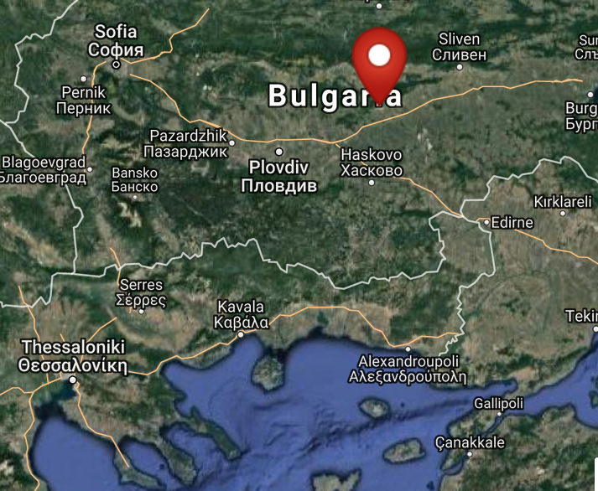

Fig. 2. Map of location of Stara Zagora, Bulgaria. From <http://latitude.to/lat/42.42604/lng/25.63356>

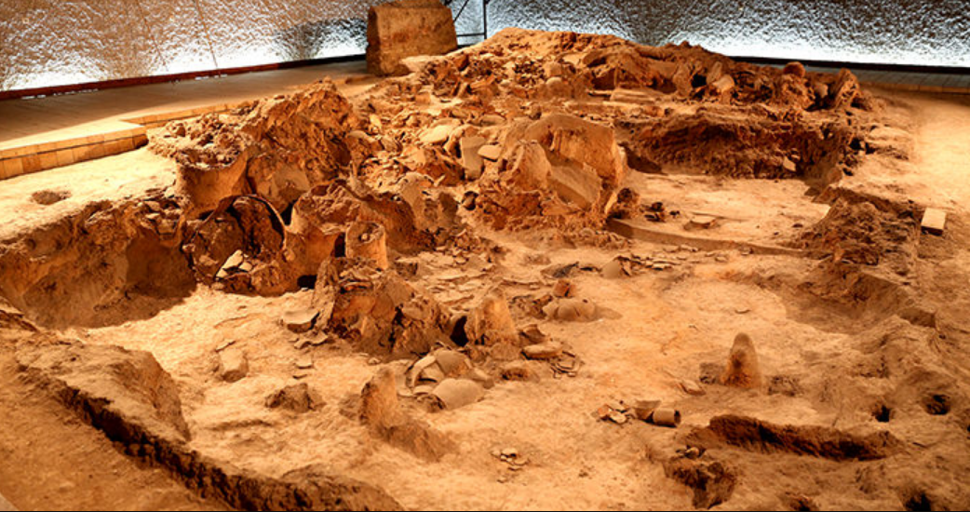

Fig. 3. Neolithic House, Stara Zagora regional Historical Museum, Bulgaria. http://www.getmetravelled.com/wp-content/uploads/2015/08/Neolithic-Dwellings-Museum_Stara_Zagora_Bulgaria.jpg

GPS coordinates: 42º25'33.74" N 25º38'0.81" E

Medium: black clay and red ochre

Dimensions: H 77 mm; W 33mm

Weight: 17 g

**Provenance:** Archaeological Museum in Stara Zagora

**Condition:** Museum Replica

**Discussion:** This figurine dates to the beginning of farming in central Europe and the use of red ochre geometric markings perhaps tattoos or body paint used in the rituals like the kuker festival. The production of ceramic figurines indicates that Stara Zagora was a sedentary society in which there was expendable time for creating amulets such as this one for individuals.

**References:**

Fol, V. 1997. “The kouker without mask. The masquerade feasts in Southern Europe. Orpheus,” *Journal of Indo-European and Thracian Studies*, 7, pp. 83-99.

Gaul, James Harvey. [1948. *The Neolithic period in Bulgaria: early food-producing cultures of Eastern Europe*](http://www.worldcat.org/title/neolithic-period-in-bulgaria-early-food-producing-cultures-of-eastern-europe/oclc/1001170812&referer=brief_results)*.*  Cambridge (Mass.): Peabody Museum.

Grębska-Kulow, M. 2016. Prehistoric Anthropomorphic Figurines with Masks as the Basis for the Kuker’s Ritual in Bulgarian Folklore. In S. Biagetti and F. Lugli. eds, *The Intangible Elements of Culture in Ethnoarchaeological Research* (pp. 201-210). Springer International Publishing.

Hansen, Svend. 2007. *Bilder vom Menschen der Steinzeit: Untersuchungen zur anthropomorphen Plastik der Jungsteinzeit und Kupferzeit in Südosteuropa* / 1 Text. [Archäologie in Eurasien](http://www.worldcat.org/search?qt=hotseries&q=se%3A%22Archa%CC%88ologie+in+Eurasien%22), 20

Mainz: Von Zabern.

Hansen, Svend. 2007. [Bilder vom Menschen der Steinzeit : Untersuchungen zur anthropomorphen Plastik der Jungsteinzeit und Kupferzeit in Südosteuropa. T. 2, Tafeln](http://www.worldcat.org/title/bilder-vom-menschen-der-steinzeit-untersuchungen-zur-anthropomorphen-plastik-der-jungsteinzeit-und-kupferzeit-in-sudosteuropa-t-2-tafeln/oclc/749227731&referer=brief_results). [Archäologie in Eurasien](http://www.worldcat.org/search?qt=hotseries&q=se%3A%22Archa%CC%88ologie+in+Eurasien%22), 20

Mainz: Von Zabern.

Kalchev, Petŭr, Neicho Kanev and Lilia Philipova. 2004. *Stara Zagora, 8000 years: the genesis of Europe*. Stara Zagora: Zonta Club.

[Krauß](http://www.worldcat.org/search?q=au%3AKrau%C3%9F%2C+Raiko.&qt=hot_author), Raiko; [Nedko Elenski](http://www.worldcat.org/search?q=au%3AElenski%2C+Nedko.&qt=hot_author" \o "Search for more by this author); [Bernhard Weninger](http://www.worldcat.org/search?q=au%3AWeninger%2C+Bernhard.&qt=hot_author); [Lee Clare](http://www.worldcat.org/search?q=au%3AClare%2C+Lee.&qt=hot_author); [Canan Çakirlar](http://www.worldcat.org/search?q=au%3AC%CC%A7akirlar%2C+Canan.&qt=hot_author" \o "Search for more by this author); [Petǎr Zidarov](http://www.worldcat.org/search?q=au%3AZidarov%2C+Peta%CC%8Cr.&qt=hot_author" \o "Search for more by this author). 2014. “Beginnings of the Neolithic in Southeast Europe: the early Neolithic sequence and absolute dates from Džuljunica-Smǎrdeš (Bulgaria),” *Documenta Praehistorica. Poročilo o raziskovanju paleolitika, neolitika in eneolitika v Sloveniji. Neolitske študije = Neolithic studies*, 41:51-77.

Perničeva, L. 2004. Anthropozoomorphe Figurinen aus dem späten neolithikum in Südwestbulgarien. In V. Nikolov & K. Băčvarov, eds., Von Domica bis Drama. Gedenkschrift für Jan Lichardus. (pp. 59–67). Sofia.

Todorova, Khenrieta. 1978. *The Eneolithic period in Bulgaria in the fifth millennium B.C*. Oxford: British Archaeological Reports.